Mob: +91-9980498160
CHANDAN KUMAR e-mail: er.chandanverm@gmail.com

Objective

To achieve a responsible position in a progressive organization that gives me a scope to apply my knowledge and skills, to be a member of a team that dynamically works towards the success and growth of the organization.

Professional Summary

- 7.8 years of Experience in the field of Windows based application development, software quality assurance with UI automation(c#), Manual database testing and Selenium Automation domain testing

- Excellent Understating of Windows based application development like Eco-Soft (Heating system application) and Andon system (Plant application system), MES_Lite (Plant Application System), Test Automation Indra Works (RPA)

- Selenium automation script writing in C# for web based application , DAS (Data Analysis system) application and Mes_Lite application

- Excellent understanding of verification and validation(RPA) of peripheral devices like Heating controller, Boilers, EMS bus controller, Room controllers, Diagnoses instrument, Industrial controller, MLC, MTX, XLC, Oscilloscope, Plc controller, CNC, Device Bridge.

- Excellent experience of verification and validation of MMM (Man, machine, material) system like Industrial Andon system, Traceability author, Traceability viewer module, Reports module, Calibration management system, Industrie 4.0 for plant support system.

- Having experience in tools like JIRA, Clear Case, IBM rational clear quest, Visual source safe, VM-ware, Virtual BOX, SQL data base, MongoDB data base, compare tool

- Extensive experience to IDE’s and Compilers like Tasking, Code Composer Studio and Embarcadero RAD studio, Visual Studio 2012 etc.

- Excellent experience of verification and validation of Industrie 4.0 domain

- Excellent experience in writing Test cases, Requirement documents, and develops manual and automated test cases and procedures.

- Having good exposure to software development life cycle (SDLC), Testing life cycle, Agile Method.

- Excellent communication, leadership, analytical and problem solving skills
- Estimation and scheduling, Overall responsible for the delivery.

Employment Summary

Joined as Associate engineer for Robert Bosch Engineering and Business Solutions Ltd, Bangalore on 18 Nov 2010.

Currently working as, a Senior Automation Testing Engineer for Robert Bosch Engineering and Business Solutions Ltd, Bangalore since Nov 2010- Till date

Technical Skills

Language : C#, .Net Framework 3.5 and 4.6, Delphi Pascal 2010,
Selenium Automation in C# (Web Driver), SQL
Controllers known : PLC, CNC, EMS
Compilers : Tasking, Code Composer Studio and IAR Workbench
Protocols known : MODBUS, UART, I2C, SPI, EMS, TCP\IP, RS 232
Operating Systems : Windows 7, 8 and 10.
Tools : Clear Case, IRQA, Enterprise Architect, Termite, VM
Ware and Virtual Box., Visual source safe, Jira,

Educational profile

B. Tech : Electronics and Instrumentation Engineering from DR.MGR University
with an aggregate of 73.74 % from 2006-2010

Intermediate : BIEC board of Intermediate Education with 53.3% from
2002 -2004.

SSC : BSEB State Board of Secondary Education with 71.78% from
2001 - 2002.

Projects involved

Project Title: Plant_support_Jap_Andon (Windows based)
Role: Team Member
Hardware Platform: Industrial Andon system
Development Environment: MS Visual Studio 2008
Tools Used: Termite –Communication Tool for Modbus
Testing Environment: Display of Actual count of produced component on Andon . System and SQL Data base
Language Platform: .Net for development of Firmware

Functional Requirements

1. Visual Audit Application: This application is responsible to capture the production as well as defect data and save into SQL database.

2. Login Module: In this module, user can logged in the application and can change their password. On successful login, application will redirect to Admin Module else, it gives login error. With the help of Change Password window, user can change their password.

3. Admin Module: Shift Configuration Management: In this module, Administrator can create the Shift timings, Shift-Break. Configuration Management: In this module, Administrator can create the different-2 types of Break during each shifts and their timings.

4. Andon Display: There will be three Andon screens for Visual Audit Station of Mid series line, which will display the production counts (as per the availability of station data in Autocal database server), Target (based on the cycle time of pump given by the customer) and delta. Screen will also display the FPY (good pump / total number of pump). This screen will auto refresh in every 5 minutes.

Application will display Message Alert on Dialog Box during the break timings. Dialog box will contain the Break types for example like ‘Lunch timings’, ‘Tea Break’, etc.
On every Visual Audit Rejection, defect (VAR) application will play a siren sound.

Testing Requirements

• Usability
The Andon will be displayed on 54-inch display.
The application should be simple easy for end user to use.
• Reliability
All known exception shall be handled appropriately by the application. In case of unexpected exception, the system shall log the exception details in the server and display relevant error message to the end user
• Maintainability
It shall be possible to host the web application on Windows 2008 server or above
• Scalability
Four Andon display will be displayed without any issue. Files will be deleted after parsed to database so that we can save size of server.

Responsibilities:

- UI design for Visual Audit Application, Login Module, Admin module Andon Display
- Coding for Login module, Admin module
- Code review
- Paper proto type
- Designing the Test cases to the coverage of customer requirements
- Involved in Unit testing.
- Preparing Test cases
- Performing Manual testing
- Review of the test cases written for Manual Testing.

Project Title: Eco- soft (Windows based)
Role: Team Member
Hardware Platform: UBA3 EMS master & Burner control system, Solar Module,
Mixer module, Hydraulic and Temperature compensation
Module, Warm water modules, Room controllers, Personal
Computer
Development Environment: Embarcadero RAD studio
Testing Environment: Waterfall method.
Language Platform: Delphi pascal

Description:
- Logamatic Ecosoft is PC based application software for the heating devices with the control systems 4000, EMS and EMSplus. It is used by the service engineer to diagnose, service, maintenance and commissioning of Buderus boilers via PC or Notebook.

- The EMS is an established for Master -slave communication system bus interface, which is Capable of controlling the powerful Boiler control network for the heat energy distribution in an efficient way.
- The EMS bus communication system provides a power interface and a communication interface to boilers with individual room controls and associated components up to 32 bus members with only a simple two-wire interface.
- The communication system for the boiler creates a number of features for a boiler such as: Individual room controls when more room controllers and mixer modules are connected to the boiler. Monitoring and controlling a boiler for service purposes.

Responsibilities:
- UI design and coding for EMS module, Diagnosis module and print module
- Designing the Test cases to the coverage of customer requirements
- Involved in Unit testing.
- Preparing Test cases
- Performing Manual testing.
- Code review and test cases written for Manual Testing.

Project Title: Eco-soft-iCom (Windows based)
Role: Team Member
Hardware Platform: iCom gateway
Development Environment: Embarcadero RAD studio
Testing Environment: Communication with Heating system over internet
Language Platform: Delphi pascal

Description:
Adding a communication module with a TCP/IP stack puts a boiler on the World Wide Web via Internet. Update of the ECO-Soft SW to internet connectivity (today: RS232, GMS, Analogue modem) “Connect the Tele Control Gateway” Upgrade of the ECO-Soft SW to connect the Junkers systems.

Adaptation and Transfer the RS232 Gateway SW to the new Ethernet gateway. Development SW interface between Gateway and ECO-Soft SW via Internet Connect the PC Delivery of all monitor data and parameter Support parameterization of all parameter

Responsibilities:
- UI design for iCOM gateway module
- Coding support for gateway module
- Code review
- Designing the Test cases to the coverage of customer requirements
- Involved in Unit testing.
- Preparing Test cases
- Performing Manual testing
- Review of the test cases written for Manual Testing.

Project Title: MEs_Lite (Web based)
Role: Team Member
Hardware Platform: CNC, PLC etc.
Development Environment: Visual studio 2012
Testing Environment: Display of Actual count of produced component on Andon system,
SQL Data base, Reports

Language Platform:

Description:
- A software product, which establishes an agile manufacturing and provides increased throughput at reduced cost. Real time visibility, Performance monitoring in manufacturing activities, Quick escalations, Productivity improvement ,Reduction in rejections ,Paperless factory floor

Functional Requirements

- Andon:
- This application is responsible to capture the production as well as defect data and save into SQL database.
- Display the Production KPI’s
- Configure the Machine/Equipment with respect to each line
- Configure the line with respect to Plant
- Configure a Marque message display
- Configure a Marque message details like Font style, Color, Size
- Configure a bandwidth for Smiley Icons (Happy, Flat and Sad Face)
- Updating the Status and color for the respective line or Machine
- Display the planned and unplanned breakdown parameters for OEE calculation
- Creation of Equipment Hierarchy as per ISA 95 standard

- Reports:
- Ability to analyze KPI’s and find root causes to problems
- Downtime reasons with codes tracked and analysed
- View the data for planned and unplanned breakdown parameters for OEE calculation
- Export the Reports in to Excel format
- Print the required data through Reports
- Track the production by accessing Reports

- Instruction Automation:
- Guide operators interactively using work instructions, component drawings, Production specifications, Manuals, Videos etc.
- Configure the Instruction either Time Based or User Acknowledgement
- Configure and display the Instruction such as HTML, File, Videos and Images
- Configure the Instruction, Product and Product variant with respect to Work center
- Configure the order of Sequence to display the Instruction
- Configure the reason against the Work center
- Update and display the status for Every instruction
- Ensuring proper completion of all work process steps

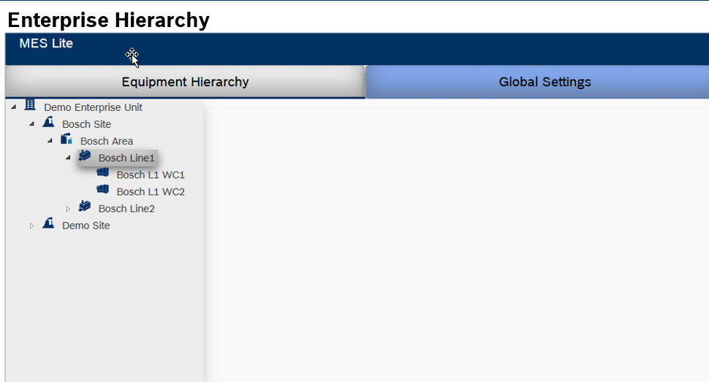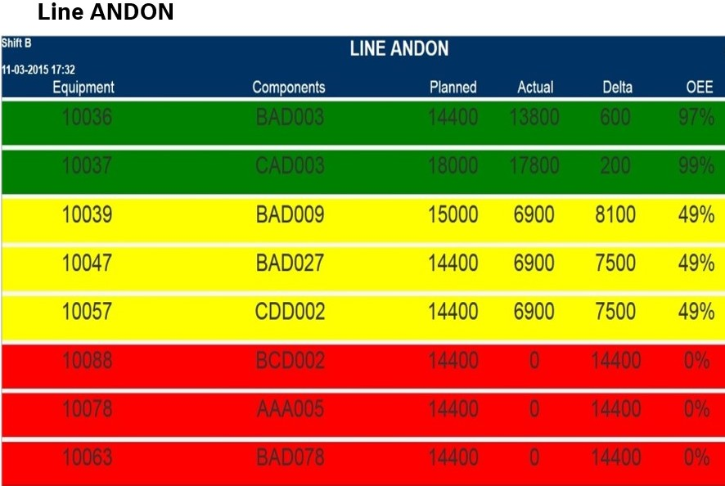

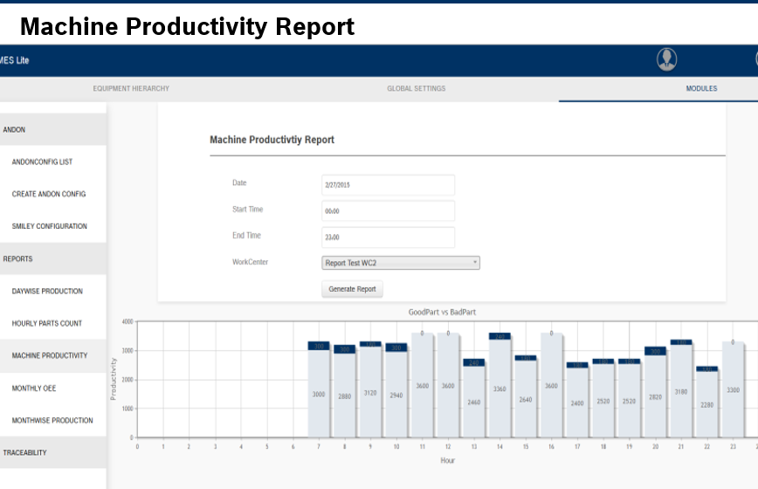

Deal with the following features like
- Product Variant Authoring
- Import Functionality for Product/Variant
- Instruction Configuration
- Viewer for Testing lines
- Viewer for Assembly lines
- Routing
- ANDON & Production Reports
- Traceability
- Electronic Work Instructions
- Production management
- Maintenance Management

Project Title: DAS (Web based)
Role: Team Member (.Net C# (Selenium) for automation testing)
Hardware Platform: CNC, PLC, MLC, XLC etc.
Development Environment: Visual studio 2012 (Selenium C#, Manual data base testing)
Testing Environment: Read data from PLC based controllers and validate the Reports.
Automation and Manual Testing

Language Platform: NET Framework 4.0

Description:
DAS is being generalized to read data from PLC based controllers. Reading/Writing Devices other than Rexroth Controllers and Drives is also in the future scope. It is use OPC UA to acquire data from devices. SCRUM is followed for das development.

Functional Requirements

^{Write data to Controller}
User can configure in reaction tab of Set up watch window to write data to controller when Alarm or warning limit crosses.

Configure IP-address with port number
Current application, location description page, IPaddress column takes only IPaddress for configuring stations. User can add IP-address with port number so that client can communicate with different port number other than 4840 port number.
If user does not add any port, number while configuring IPaddress then application automatically adds default port number 4840 for that IPaddress.

Load variable page compatible with namespaceuri
Set up load variable and information load variable page should work with namespace uri. User has to add variable in set up load variable page and can see live data from controller in information load variable page.

^{RCM_Calender_Task}

When alarm and warning limit crosses for a datapoint then in RCM Organization maintenance plan page one task should get created with description that a particular datapoint of certain device/controller has crossed certain limit. In database, one table should be created with name as TCreateTaskonCalenderInfo, which has columns with ‘id, ‘locationindicator id’ and ‘task created status’.

Deal with the following features like
- Object Location
- Object Table
- Trigger
- Configuring messaging.
- Read data from controller.
- Write data to Mongo DB database and Controller.
- Limit (This task is used to assign a limit to the variable’s value while reading and writing it. If the value exceeds or goes below the limit, message needs to be sent).
- Activity status (The activity status task can be sub categorized in two sections. One section gives the information about the current status of activity and other gives the information about errors, if any occurred at the time of execution of activity).
- Reports.
- MongoDB database

Project Title: IndraWorks (Windows based)
Role: Team Lead
Hardware Platform: CNC, PLC, MLC, XLC, Rexroth controllers etc.
Development Environment: .NET Framework 4.0
Testing Environment: Testing is performed in VM-ware and Virtual box with White box
and black box methods are followed.

Description: Indralogic is the programming tool used to program Indracontrols and indradrives
- User-friendly programming of motion control application with interpolation in 3D
- Multi-kinematics
- Variety of ready-to-use transformations for standard applications of Robotics
Extensible with own PLC transformations
- Dialog-based configuration and parameterization
- PLC open compliant programming and data interface
- Kinematics interface3 steps to a ready-to-use kinematics
- Available with Motion-Logic-System IndraMotion MLC

Deal with the following features like
- DDP
- User Management
- Archive- Restore
- Import- Export
- VCS
- Compare Tool
- Print
- Oscilloscope
- IndraLogic
- HMI
- OPD

Deal with the following Test Module
- Basis test
- Automation Interface
- CoDeSys Analysis
- HMI Compatibility Test
- OscilloscopeTest
- HMI_Communication Test
- Print Test
- HMI Multitouch Screen Test
- HMI Winstudio Test
- Platform_Compatibility
- HMI Winstudio Test
- HMI_Communication Test
- Integration test

Deal with the following Random Test
- Access Rights
- Authenticated, Authorized
- Performance Tests
- Load Test, Regressions
- Frequently used
- Copy/Paste, Import/Export
- New features
- GUI Changes ,H/W Integration
- Compatibility
- Backward/Forward, Versions
- Data Validation
- Boundary Value, Invalid Inputs

Project Title: CMS (Calibration management system, Web Based)
Role: Team Member (Selenium (.Net C#) Automation Testing, Database
Manual Testing)
Hardware Platform: CNC, PLC etc.
Development Environment: Client: Mozilla Firefox ver 24.7 and above Server: Windows
Server 2008, Microsoft IIS 7.0.
Testing Environment: Display of Actual count of produced component on Andon system,
Oracle 10g and above Database shall be used.
Language Platform: .NET Framework 4.0

Description:
- A software which deals for calibration management, Notification and calibration report. The software should manage calibration information and notify different users about the status of the calibration.

Functional requirements

- Configuration system
Configuration system of CMS software should allow the users to configure the devices, which need to be calibrated, Mail notification configuration.

- Reporting system
Reporting system should provide calibration report, not calibrated devices and graphical representation of calibration report summary.

- Calibration Management System
Calibration Information system should provide facility add calibration details and view details of calibration of different devices.
- Notification System
Notification system should convey message to specified users about calibration via mail.

Deal with the following features like
- Login Screen
- Configuration- Calibration Due Mail
- Configuration- Calibration acknowledge Mail
- Configuration- Calibration acknowledge Mail
- Configuration Settings – Add Supplier
- Add Calibration Info
- Edit Calibration Info
- Deactivate/Delete Calibration Info
- Line info report/ QMM Machine Info/ Calibration Due report
- Label Printing
- Calibration Summary
- Add Calibration Not Required Device
- Calibration Redundant Devices List
- SAP Integration
- Calibration History
- Edit User Screen
- Add Group Screen

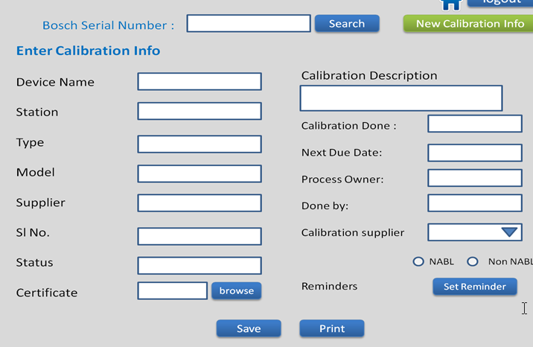

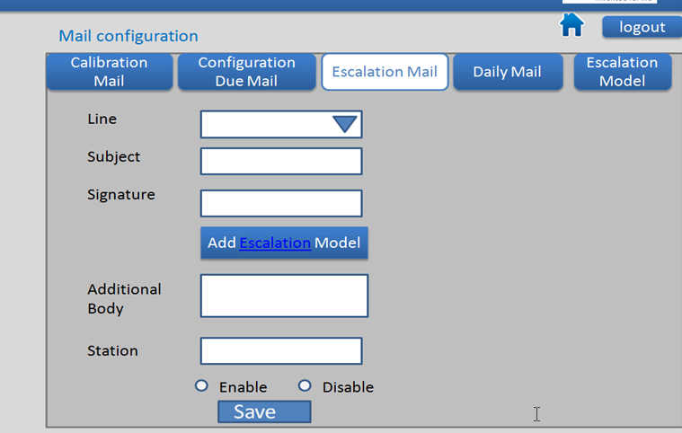

(Chandan Kumar)

